Hot lunches for sale in the cafeteria on Thursday’s!
Please pre order and pay for your lunch no later than the day before lunch is being served.

October 24th – Chicken nuggets and fries $5.00
October 31st – Waffles $4.00

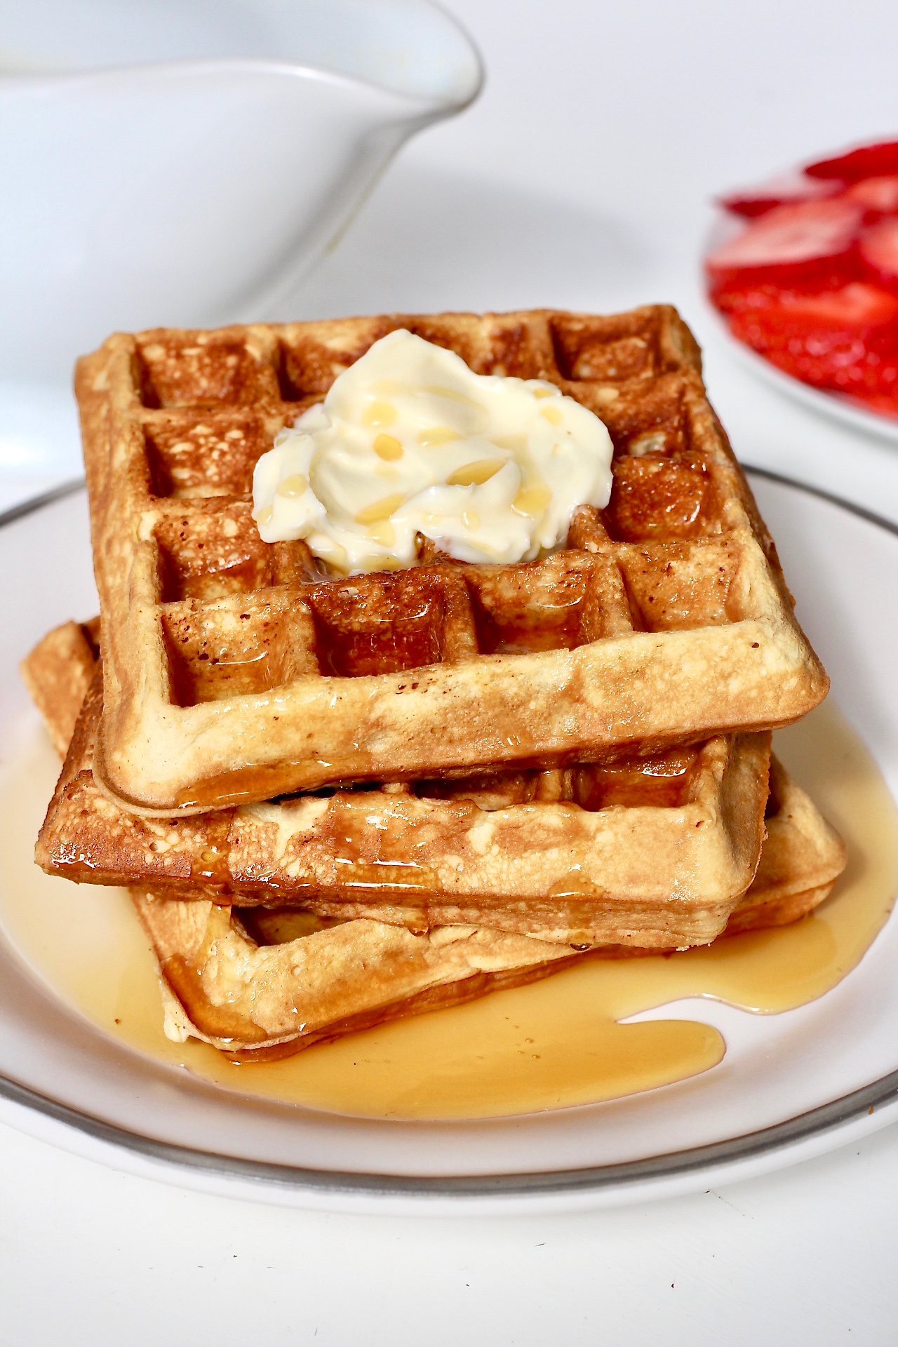

November 7th – Grilled Cheese $2.50
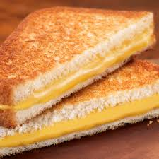
November 14th – Egg, ham, cheese on muffin $3.50
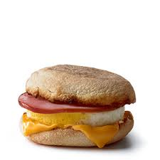
November 21st – Hot Dogs 2 for $3.00
