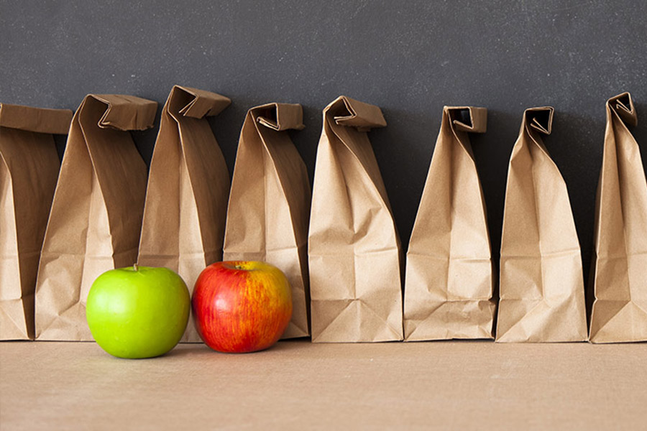

Paper Bag Lunches

Pop into Cole Harbour Public
Library on Fridays 10:30am or later and make yourself a lunch to go!
Starting on January 10th, 2020

